SUPPLEMENT

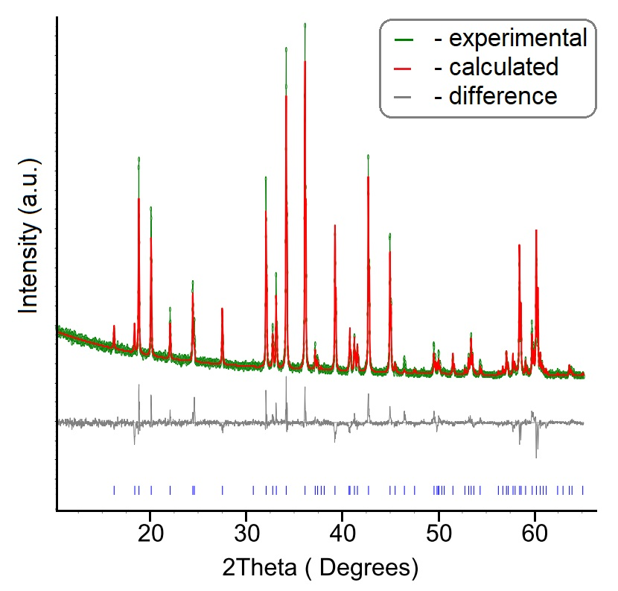

Fig. S1. X-ray pattern of PrMgAl₁₁O₁₉ specimen.

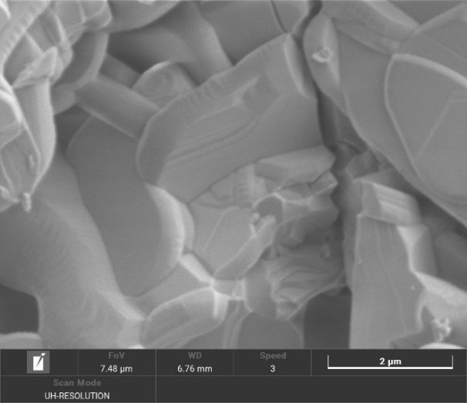

Fig. S2. Morphology of PrMgAl₁₁O₁₉ surface after calcination at 1700°C.
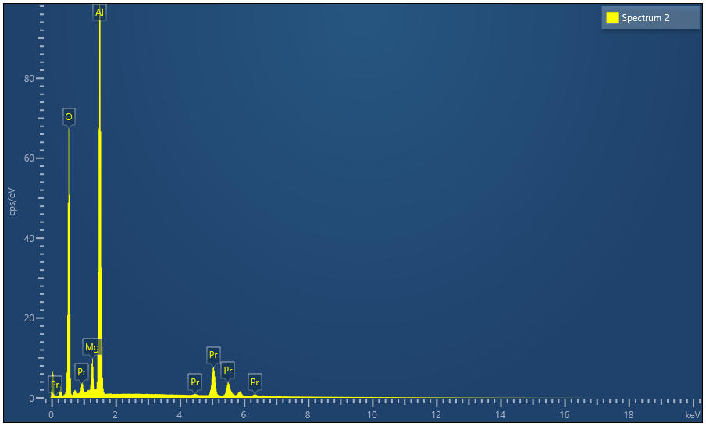
Fig. S3. EDX-pattern of PrMgAl₁₁O₁₉ specimen.

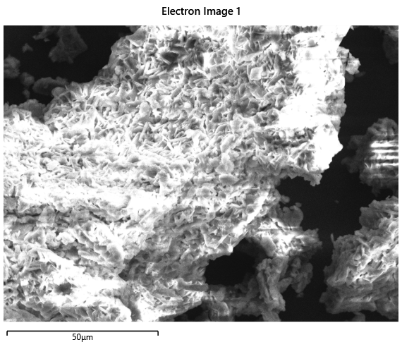
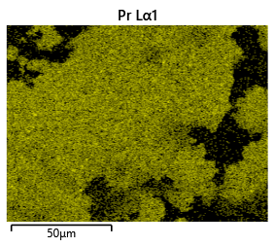 | 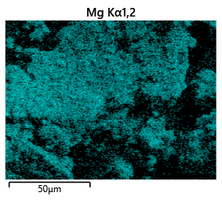
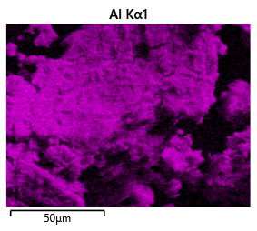 | 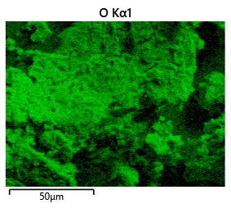
Fig. S4. Mapping of elements distribution for PrMgAl₁₁O₁₉ specimen.

Fig. S5 – Temperature dependences of the real (χ') and imaginary (χ") parts of the dynamic magnetic susceptibility of the PrMgAl₁₁O₁₉ sample in a zero external magnetic field at different frequencies of the alternating magnetic field. The amplitude of the alternating magnetic field is 1 Oe.

Fig. S6. Comparison of the temperature dependence of the real (χ', black circles) and imaginary (χ", blue squares) parts of the dynamic magnetic susceptibility of the PrMgAl₁₁O₁₉ sample in a zero magnetic field at an alternating magnetic field frequency of 1000 Hz. The amplitude of the alternating magnetic field is 1 Oe.

Fig. S7. Temperature dependences of the imaginary (χ") part of the dynamic magnetic susceptibility of the PrMgAl₁₁O₁₉ sample in a zero external magnetic field at an alternating magnetic field frequency of 1000 Hz, the amplitude of the alternating magnetic field is 1 Oe (blue empty symbols) and 10 Oe (red filled symbols).

Fig. S8. Temperature dependences of the imaginary (χ") part of the dynamic magnetic susceptibility of the PrMgAl₁₁O₁₉ sample in a zero external magnetic field (empty symbols, thin lines) and in an external magnetic field of 1000 Oe (filled symbols, thick lines) at alternating magnetic field frequencies of 500 Hz (black) and 900 Hz (red), the amplitude of the alternating magnetic field is 1 Oe.

Fig. S9. Temperature dependences of the imaginary (χ") part of the dynamic magnetic susceptibility of the PrMgAl₁₁O₁₉ sample in an external magnetic field of 1000 Oe. The amplitude of the alternating magnetic field is 1 Oe.

Table S1. Experimental heat capacity values PrMgAl₁₁O₁₉ ( J/(K·mol).
T, K |  | C_{p.m}, |  | T, K |  | C_{p.m}, |  | T, K |  | C_{p.m}, |  | T, K |  | C_{p.m},
Relaxation calorimetry (sample mass 0.01794 g)
2.112 |  | 0.5208 |  | 4.443 |  | 1.219 |  | 10.064 |  | 2.430 |  | 19.419 |  | 4.737
2.351 |  | 0.5928 |  | 4.821 |  | 1.318 |  | 10.925 |  | 2.555 |  | 21.090 |  | 5.408
2.600 |  | 0.6727 |  | 5.225 |  | 1.419 |  | 11.874 |  | 2.723 |  | 22.885 |  | 6.199
2.863 |  | 0.7521 |  | 5.662 |  | 1.561 |  | 13.052 |  | 2.907 |  | 24.943 |  | 7.447
3.145 |  | 0.8352 |  | 6.122 |  | 1.686 |  | 14.059 |  | 3.131 |  | 26.991 |  | 8.909
3.441 |  | 0.9253 |  | 7.899 |  | 2.066 |  | 15.230 |  | 3.412 |  | 29.288 |  | 10.53
3.753 |  | 1.018 |  | 8.570 |  | 2.169 |  | 16.498 |  | 3.790 |  | 31.705 |  | 12.36
4.089 |  | 1.117 |  | 9.294 |  | 2.288 |  | 17.886 |  | 4.221 |  | 34.496 |  | 14.73
Adiabatic calorimetry (sample mass 1.33952 g)
23.79 |  | 6.732 |  | 92.52 |  | 103.5 |  | 164.44 |  | 278.6 |  | 234.84 |  | 426.9
25.41 |  | 7.806 |  | 94.46 |  | 107.9 |  | 166.38 |  | 283.0 |  | 236.71 |  | 430.3
27.12 |  | 8.988 |  | 96.41 |  | 112.3 |  | 168.30 |  | 287.8 |  | 238.58 |  | 433.5
28.85 |  | 10.24 |  | 98.36 |  | 116.9 |  | 170.23 |  | 292.3 |  | 240.45 |  | 436.7
30.59 |  | 11.53 |  | 100.30 |  | 121.5 |  | 172.16 |  | 296.9 |  | 242.31 |  | 439.9
32.34 |  | 12.98 |  | 102.23 |  | 126.0 |  | 174.09 |  | 301.6 |  | 244.17 |  | 443.2
34.11 |  | 14.36 |  | 104.16 |  | 130.3 |  | 176.01 |  | 305.5 |  | 246.03 |  | 446.4
35.87 |  | 15.97 |  | 106.11 |  | 135.0 |  | 177.94 |  | 309.9 |  | 247.89 |  | 449.6
37.67 |  | 17.43 |  | 108.06 |  | 139.6 |  | 179.86 |  | 314.5 |  | 249.75 |  | 452.8
39.46 |  | 19.21 |  | 110.01 |  | 144.0 |  | 181.78 |  | 319.0 |  | 252.55 |  | 456.4
41.28 |  | 20.88 |  | 111.95 |  | 149.0 |  | 183.70 |  | 323.7 |  | 256.41 |  | 463.6
43.10 |  | 22.68 |  | 113.90 |  | 153.9 |  | 185.62 |  | 327.7 |  | 260.23 |  | 469.7
44.92 |  | 24.58 |  | 115.85 |  | 158.4 |  | 187.54 |  | 332.2 |  | 264.06 |  | 475.9
46.76 |  | 26.57 |  | 117.80 |  | 163.1 |  | 189.46 |  | 335.8 |  | 267.87 |  | 482.0
48.61 |  | 29.14 |  | 119.75 |  | 168.2 |  | 191.37 |  | 340.2 |  | 271.69 |  | 488.0
50.47 |  | 31.25 |  | 121.69 |  | 173.0 |  | 193.29 |  | 344.7 |  | 275.49 |  | 493.9
52.48 |  | 33.03 |  | 123.64 |  | 178.0 |  | 195.20 |  | 348.6 |  | 279.27 |  | 499.3
54.34 |  | 35.41 |  | 125.59 |  | 182.8 |  | 197.11 |  | 352.8 |  | 283.07 |  | 504.8
56.22 |  | 37.90 |  | 127.54 |  | 187.5 |  | 199.02 |  | 357.3 |  | 286.86 |  | 509.9
58.10 |  | 40.59 |  | 129.49 |  | 192.7 |  | 200.93 |  | 361.4 |  | 290.64 |  | 514.9
59.99 |  | 43.25 |  | 131.44 |  | 197.7 |  | 202.79 |  | 364.9 |  | 294.42 |  | 519.6
61.88 |  | 45.95 |  | 133.39 |  | 202.5 |  | 204.69 |  | 368.8 |  | 298.18 |  | 524.3
63.79 |  | 48.79 |  | 135.34 |  | 207.3 |  | 206.59 |  | 372.9 |  | 301.82 |  | 529.9
65.69 |  | 51.75 |  | 137.29 |  | 212.2 |  | 208.49 |  | 376.9 |  | 305.55 |  | 533.3
67.59 |  | 54.81 |  | 139.23 |  | 216.9 |  | 210.38 |  | 380.7 |  | 309.27 |  | 537.6
69.51 |  | 58.19 |  | 141.18 |  | 222.0 |  | 212.26 |  | 384.2 |  | 312.99 |  | 542.2
71.42 |  | 61.58 |  | 143.13 |  | 226.8 |  | 214.15 |  | 388.3 |  | 316.70 |  | 546.6
73.34 |  | 64.98 |  | 145.08 |  | 231.5 |  | 216.04 |  | 391.9 |  | 320.40 |  | 551.1
75.26 |  | 68.63 |  | 147.02 |  | 236.4 |  | 217.93 |  | 395.4 |  | 324.10 |  | 555.4
77.19 |  | 72.45 |  | 148.97 |  | 241.3 |  | 219.81 |  | 398.7 |  | 327.79 |  | 559.4
77.42 |  | 72.65 |  | 150.91 |  | 246.1 |  | 221.70 |  | 402.2 |  | 331.47 |  | 563.2
80.90 |  | 78.41 |  | 152.84 |  | 251.3 |  | 223.58 |  | 405.8 |  | 335.14 |  | 567.3
82.82 |  | 82.47 |  | 154.77 |  | 255.4 |  | 225.46 |  | 409.3 |  | 338.81 |  | 571.2
84.76 |  | 86.58 |  | 156.71 |  | 260.1 |  | 227.34 |  | 412.8 |  | 342.47 |  | 574.6
86.70 |  | 90.61 |  | 158.65 |  | 264.9 |  | 229.22 |  | 416.1 |  | 346.12 |  | 578.5
88.64 |  | 94.90 |  | 160.58 |  | 269.3 |  | 231.09 |  | 419.7
90.58 |  | 99.20 |  | 162.51 |  | 274.2 |  | 232.97 |  | 423.4
Differential scanning calorimetry (sample mass 0.03572 g)
335 |  | 566.1 |  | 725 |  | 750.3 |  | 1115 |  | 806.9 |  | 1505 |  | 848.1
345 |  | 577.7 |  | 735 |  | 752.1 |  | 1125 |  | 807.7 |  | 1515 |  | 848.8
355 |  | 588.5 |  | 745 |  | 753.2 |  | 1135 |  | 808.9 |  | 1525 |  | 849.1
365 |  | 598.4 |  | 755 |  | 754.7 |  | 1145 |  | 809.8 |  | 1535 |  | 849.7
375 |  | 607.8 |  | 765 |  | 756.4 |  | 1155 |  | 810.6 |  | 1545 |  | 850.6
385 |  | 616.6 |  | 775 |  | 757.7 |  | 1165 |  | 812.5 |  | 1555 |  | 851.3
395 |  | 624.6 |  | 785 |  | 759.1 |  | 1175 |  | 814.2 |  | 1565 |  | 852.1
405 |  | 632.1 |  | 795 |  | 760.9 |  | 1185 |  | 815.2 |  | 1575 |  | 853.7
415 |  | 639.0 |  | 805 |  | 762.7 |  | 1195 |  | 816.0 |  | 1585 |  | 855.7
425 |  | 645.4 |  | 815 |  | 764.7 |  | 1205 |  | 815.8 |  | 1595 |  | 857.6
435 |  | 651.7 |  | 825 |  | 766.3 |  | 1215 |  | 816.4 |  | 1605 |  | 858.9
445 |  | 657.3 |  | 835 |  | 767.3 |  | 1225 |  | 818.6 |  | 1615 |  | 860.0
455 |  | 663.1 |  | 845 |  | 768.6 |  | 1235 |  | 820.5 |  | 1625 |  | 861.5
465 |  | 668.6 |  | 855 |  | 770.6 |  | 1245 |  | 821.5 |  | 1635 |  | 862.3
475 |  | 673.8 |  | 865 |  | 773.0 |  | 1255 |  | 822.7 |  | 1645 |  | 863.1
485 |  | 678.6 |  | 875 |  | 774.8 |  | 1265 |  | 823.6 |  | 1655 |  | 865.8
495 |  | 683.0 |  | 885 |  | 776.4 |  | 1275 |  | 824.5 |  | 1665 |  | 867.6
505 |  | 687.1 |  | 895 |  | 777.7 |  | 1285 |  | 825.2 |  | 1675 |  | 867.1
515 |  | 690.8 |  | 905 |  | 778.6 |  | 1295 |  | 826.1 |  | 1685 |  | 867.9
525 |  | 694.1 |  | 915 |  | 779.7 |  | 1305 |  | 827.2 |  | 1695 |  | 870.2
535 |  | 697.5 |  | 925 |  | 781.5 |  | 1315 |  | 828.4 |  | 1705 |  | 871.2
545 |  | 701.1 |  | 935 |  | 783.3 |  | 1325 |  | 829.6 |  | 1715 |  | 872.1
555 |  | 704.4 |  | 945 |  | 785.1 |  | 1335 |  | 830.6 |  | 1725 |  | 872.0
565 |  | 707.4 |  | 955 |  | 786.4 |  | 1345 |  | 831.5 |  | 1735 |  | 871.4
575 |  | 710.6 |  | 965 |  | 787.9 |  | 1355 |  | 832.1 |  | 1745 |  | 871.8
585 |  | 713.7 |  | 975 |  | 788.7 |  | 1365 |  | 834.0 |  | 1755 |  | 872.5
595 |  | 716.6 |  | 985 |  | 789.4 |  | 1375 |  | 836.6 |  | 1765 |  | 873.0
605 |  | 719.5 |  | 995 |  | 790.5 |  | 1385 |  | 837.7 |  | 1775 |  | 874.0
615 |  | 722.0 |  | 1005 |  | 791.3 |  | 1395 |  | 838.4 |  | 1785 |  | 874.7
625 |  | 724.9 |  | 1015 |  | 792.9 |  | 1405 |  | 839.6 |  | 1795 |  | 874.4
635 |  | 727.8 |  | 1025 |  | 795.5 |  | 1415 |  | 840.7 |  | 1805 |  | 877.1
645 |  | 730.5 |  | 1035 |  | 796.9 |  | 1425 |  | 841.5 |  | 1815 |  | 879.7
655 |  | 733.2 |  | 1045 |  | 798.1 |  | 1435 |  | 842.2 |  | 1825 |  | 881.8
665 |  | 736.0 |  | 1055 |  | 799.4 |  | 1445 |  | 843.2 |  | 1835 |  | 881.8
675 |  | 738.6 |  | 1065 |  | 800.5 |  | 1455 |  | 844.3 |  | 1845 |  | 883.5
685 |  | 740.7 |  | 1075 |  | 801.5 |  | 1465 |  | 845.4 |  | 1855 |  | 883.7
695 |  | 743.1 |  | 1085 |  | 802.1 |  | 1475 |  | 846.1 |  | 1865 |  | 884.9
705 |  | 745.6 |  | 1095 |  | 803.6 |  | 1485 |  | 846.2
715 |  | 748.0 |  | 1105 |  | 805.8 |  | 1495 |  | 847.1

Table S2. Coefficients of equations (1) and (2) used to calculate the heat capacity values of PrMgAl₁₁O₁₉ in the range 0–1865 K.
Range |  | Coefficient |  | Coefficient value
Equation (1)
0–2.75 K |  | a |  | 3.8042×10⁻³
0–2.75 K |  | b |  | 2.3187×10⁻¹
Equation (2)
2.75–7.90 K |  | A₀ |  | 1.6167
2.75–7.90 K |  | A₁ |  | –2.4705
2.75–7.90 K |  | A₂ |  | 1.7922
2.75–7.90 K |  | A₃ |  | –0.60558
2.75–7.90 K |  | A₄ |  | 0.11575
2.75–7.90 K |  | A₅ |  | –1.2562×10⁻²
2.75–7.90 K |  | A₆ |  | 7.1787×10⁻⁴
2.75–7.90 K |  | A₇ |  | –1.6734×10⁻⁵
Equation (3)
7.90–1865 K |  | α₁ |  | 7.3637992076688
7.90–1865 K |  | α₂ |  | 17.030256888506
7.90–1865 K |  | α₃ |  | 12.91367179021
7.90–1865 K |  | α₄ |  | 2.138948805634
7.90–1865 K |  | α₅ |  | 0.2655114780674
7.90–1865 K |  | α₆ |  | 0.10966105797763
7.90–1865 K |  | θ₁ |  | 6009.2321947938
7.90–1865 K |  | θ₂ |  | 926.93327473745
7.90–1865 K |  | θ₃ |  | 465.42574281516
7.90–1865 K |  | θ₄ |  | 180.93273497174
7.90–1865 K |  | θ₅ |  | 83.148916151664
7.90–1865 K |  | θ₆ |  | 14.959326835402

