*Russian Journal of Plant Physiology, 2024, V. 71, № 1*

**SUPPLEMENTARY INFORMATION**

**USE OF BROMOCRESOL GREEN FOR THE SPECTROPHOTOMETRIC DETERMINATION OF ALKALOIDS IN THE EXAMPLE OF *Ruta graveolans***

**A. I. Valieva*а*, *, А. N. Akulov*а***

*a* *Kazan Institute of Biochemistry and Biophysics of FRC Kazan Scientific Center of Russian Academy of Sciences, Kazan,* *Russian Federation*

*Corresponding author:* *Valieva A. I.*

*\*e-mail:* [*cell-culture@yandex.ru*](mailto:cell-culture@yandex.ru)

**Table 1.** Optical density at λmax of the bromocresol-alkaloid ion pair at different residence times in the reaction mixture prior to extraction of the ion pair with chloroform.

|  |  |  |  |
| --- | --- | --- | --- |
| Alkaloid  Residence times | Atropine sulfate | Papaverine hydrochloride | Nicotine |
| 1 min | 0.199 ± 0.027 *a* | 0.197 ± 0.012 *a* | 0.187 ± 0.021 *a* |
| 5 min | 0.208 ± 0.013 *a* | 0.206 ± 0.008 *a* | 0.192 ± 0.002 *a* |
| 10 min | 0.216 ± 0.011 *a* | 0.197 ± 0.01 *a* | 0.194 ± 0.006 *a* |
| 30 min | 0.216 ± 0.025 *a* | 0.173 ± 0.019 *a* | 0.172 ± 0.010 *a* |

Note. Non-significant differences in mean values (*P* ≤ 0.05) are marked with the same letters.

**Table 2.** Optical characteristics and sensibility range of the assay

|  |  |  |  |  |
| --- | --- | --- | --- | --- |
| Parameters  Alkaloid | λmax, nm | Linear dependence range, µg/mL | Equation | Correlation coefficient |
| Atropine sulfate | 417 | 2–10 | y = 0.0521x | R2 = 0.9977 |
| Papaverine hydrochloride | 418 | 3–10 | y = 0.0461x | R2 = 0.9599 |
| Nicotine | 414 | 4–10 | y = 0.0405x | R2 = 0.9661 |

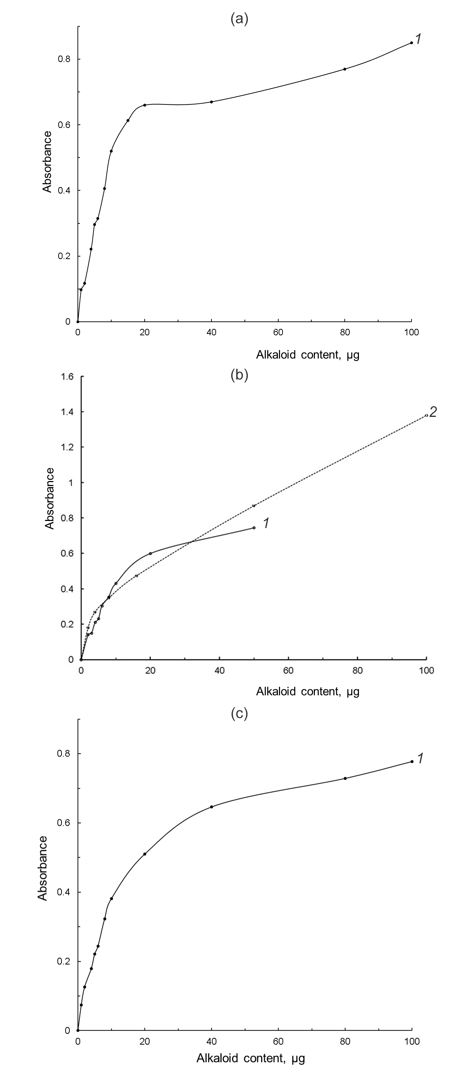

**Figure S1.** Calibration curves for atropine sulfate (a), papaverine hydrochloride (b), nicotine (c). For atropine sulfate and nicotine, 0.1 mM bromocresol green (BCG) was used in the reaction mixture, and 0.1 mM (*1*, solid line) and 0.5 mM (*2*, dashed line) BCG was used for papaverine hydrochloride.

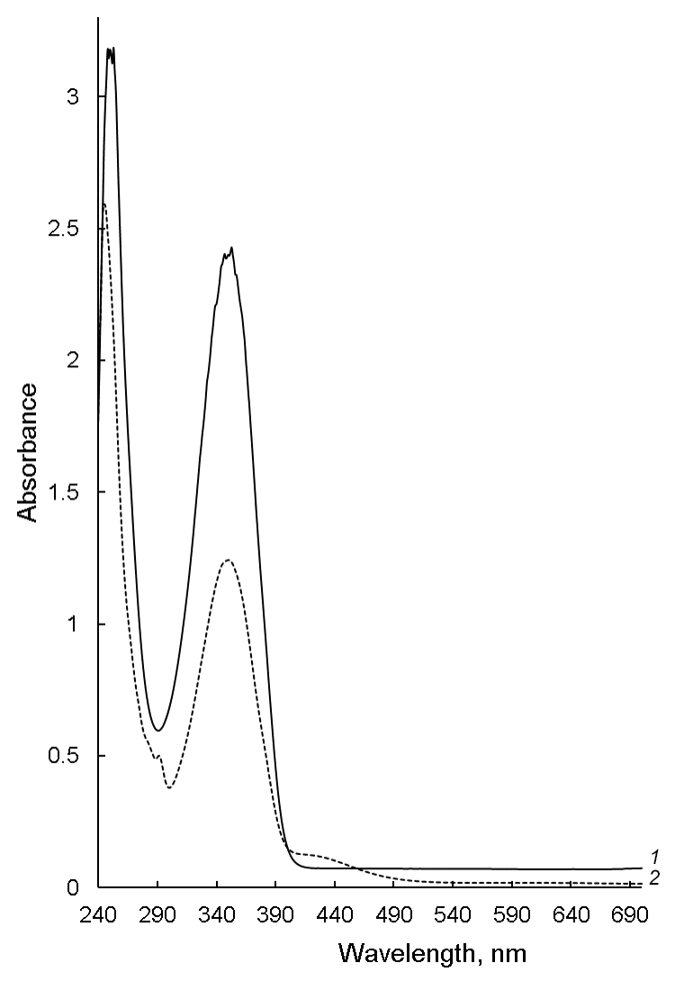

**Figure S2.** Absorption spectra of colchicine dissolved in chloroform (*1*, solid line) and of mixture of bromocresol green and colchicine (*2*, dashed line).

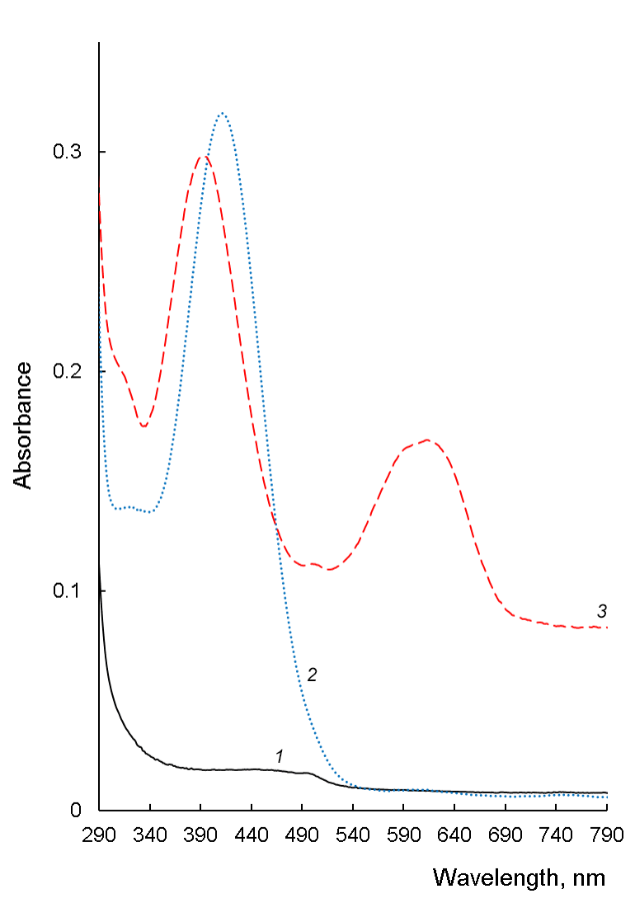

**Figure S3.** Absorption spectra of nicotine dissolved in chloroform (*1,* black solid line) and bromocresol green-nicotine ion pair before alkalinization (*2,* blue dotted line) and after alkalinization (*3,* red dashed line).

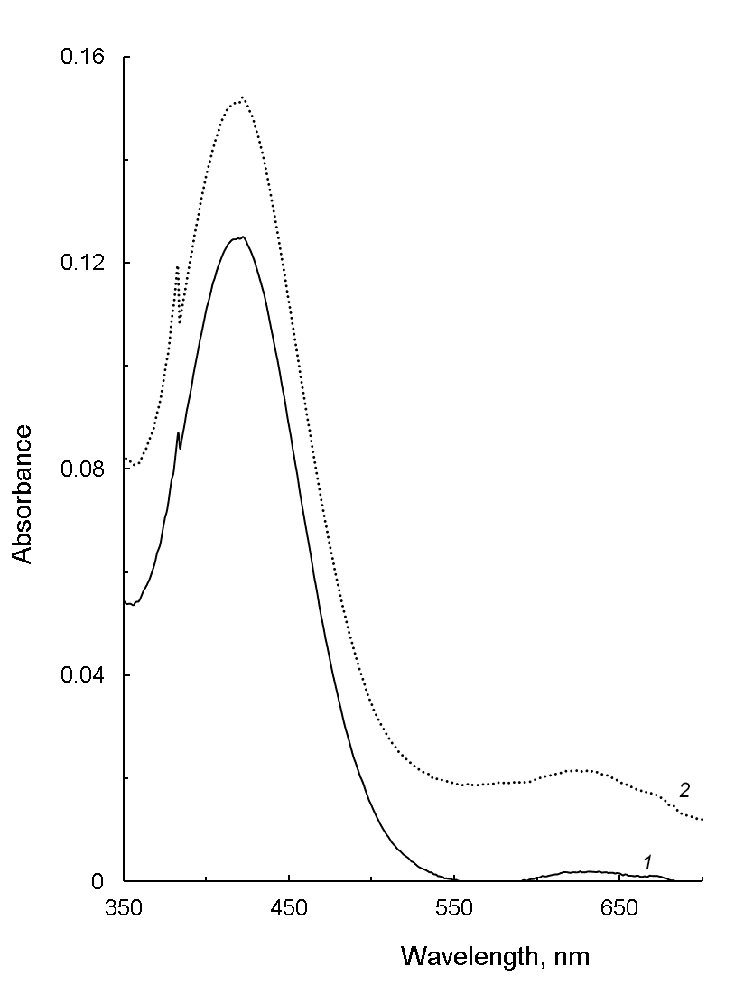

**Figure S4.** Absorption spectra of blank solutions prepared with different concentrations of bromocresol green: 10-4 M (solid line, *1*) and 5∙10-4 M (dotted line, *2*).

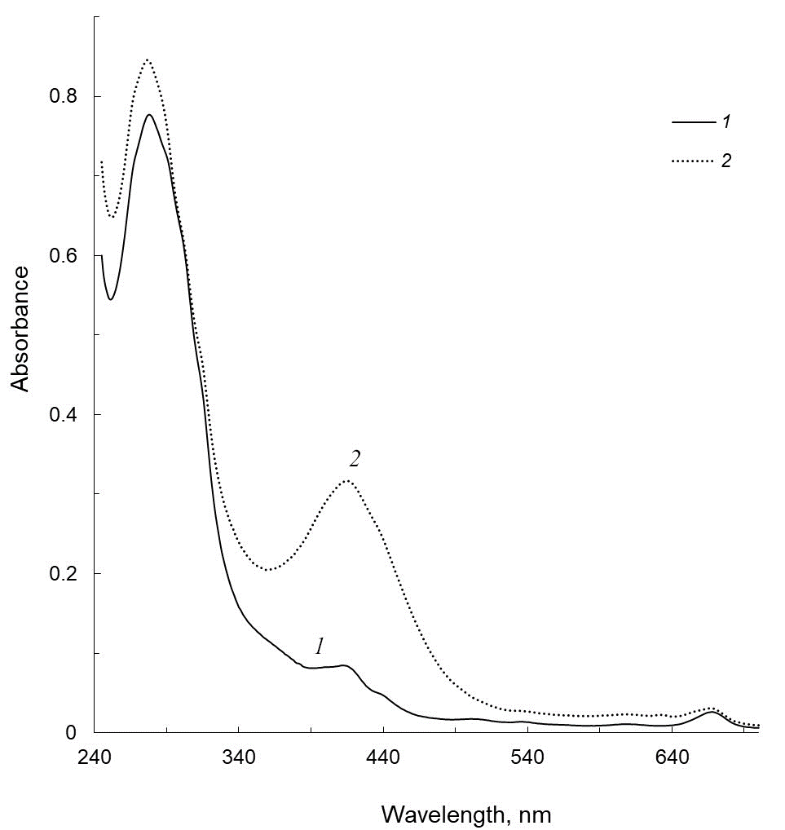

**Figure S5.** Absorption spectra of a sample of pharmacy medicine “Herba Ruta graveolens” measured before (solid line, *1*) and after (dashed line, *2*) addition of bromocresol green.